Summary
Elevate Health Group (EHG) is a primary care physician's office that is facing a problem with critical lab results turnaround time. EHG utilizes in-house laboratory and they have grown in the number of their patients which is making it impossible for the lab to get the lab results in a timely manner to avoid delays in patient care. The benefits of outsourcing the lab are endless. For example, decreasing in cost, quicker turnaround time for the lab results...etc.
Answer the following:
- Describe at least two different solutions and data requirements for both - Describe how each potential solution would change the flowchart and address the management objectives.
- What data or information would you like to have, and do you have? (Determination of data requirements and availability.)
- What quantitative tool would be best for this particular problem? Describe the pros and cons of a particular tool that you could use to evaluate the alternative solutions: BEA? Decision Table? Other?
- Literature review focusing on the successes and failures of selected decision tools. – Management examples when it is appropriate to use decision tool. –Related the literature to your management decision-making problem.
- If you could actually run the quantitative tool how would you interpret the results–Think about using one of the homework problems as the basis for your quantitative model.
- Having thought about this problem and learned various quantitative decision tools, what do you think the best solution would be? (Pretend you know what you are doing.)
- Having thought about this problem and learned various quantitative decision tools, what do you think the best solution would be? (Pretend you know what you are doing.)
Paper structure: The paper needs to include the following: Make sure you side-title all these parts in the paper:
1. Preliminary Observations: What is the environment of the organization?
2. Problem description: Defining the problem to be solved.
3. Illustration of the problem system (Use the provided flow chart in the attached word document) and explain the problem.
4. Two different solutions and data requirements (You need to create pretend data) (Please refer to the word document that includes the 2 solutions).
5. Preliminary examination of data/information.
6. Literature search and review.
7. Analytical techniques: Cost-benefit analysis (Include excel Net present value (NPV) worksheet for solution 1 and 2) (please refer to word document it has a sample NPV)
8. Payoff table/Decision table (please include a general payoff matrix)
9. Run the analysis.

Background Information
Elevate Health Group is a primary care physician’s office that has been facing some challenges with the turnaround time when it comes to laboratory results. EHG has been working with the same laboratory got over 4 years and this has never been an issue before. The normal turnaround time for the laboratory is anywhere between 2 to 7 days depending on the type of test and the urgency of the request. The numbers of patients at EHG has been rapidly growing over the years, and it might be part of the reason why a small laboratory is unable to keep up with all the requests being sent to them. Receiving late lab results, especially critical labs is extremely inconvenient, and it could cause major health problems to the involved patients. EHG needs to invest into a new contract with a larger laboratory that is able to timely handle the numbers of lab orders being sent out on daily basis.
The objective in solving this problem is to get the lab results sent back to the office/physician as fast as possible. This will allow the doctors to review all the critical labs first and come up with a treatment plan for each and every patient involved. It will also allow the staff members to call these patients and schedule follow-up appointment so that the physicians are able to explain and educate the patients on what needs to be done. The improvement plan is to shorten the turnaround time for critical lab results to avoid any interruption in patient care. This will automatically improve patient care and will help the patients in receiving better medical care and health outcomes. It will also allow the physicians to do what they are supposed to by delivering the best care for all of their patients. The improvement plan will also make the patients of EHG see and understand the involvement of their doctors and/or the office staff in their healthcare and it will help building a trusted relationship between all the stakeholders. The tools that would be used to assess this problem is by first researching large laboratories and review their values and make sure they align with the values of EHG. Moreover, the staff needs to start tracking the urgent lab requests being sent and the time duration for the results to come back. Using excel spreadsheets and the patient portal will help getting the job done by tracking the times when a request is being sent and the times the results are being collected. The physicians will then be able to determine if the change of laboratory has made a difference in patient care and/or if there is a different issue to address.

Part 2:
- Describe at least two different solutions to your problem and describe the data requirements for each solution.

Solution 1: Outsourcing the laboratory services. The office manager needs to do research to be able to determine which lab to contract with for the needed services. This will allow the office to reduce cost and to have a faster turnaround time for the diagnostic testing which will better patient care and satisfaction rates. The following questions should be asked to each laboratory to be able to make the decision:
- What is the turnaround time for urgent/non-urgent lab orders?
- How many different offices is the laboratory contracted with?
- What is the pick-up/drop-off times/schedule for the specimen?
- What communications tools are used by the laboratory staff?
- In cases of emergencies, would the laboratory be able to do extra trips to pick-up specimen?
- What are the financials details when it comes to contracting with the laboratory?
- What is the length of the contract?
These questions should help the physicians and the office managers to come up with an educated decision on which lab to contract with. Moreover, since there will be cost reduction, the office would be able to hire an extra staff member that will be assigned to follow-up and work directly with the laboratory.
Solution 2: Buying out the small laboratory the office is currently using for their lab needs and taking over the whole lab. This will work because the lab would only do the tests our doctors send out and they will not have contracts with different physicians’ offices and that way they will be able to handle the increased volume of the patients we are having. Please make sure to do break even analysis for both solutions and picking the one that makes more sense and the one that would be more successful.

NPV Example
I have also attached an excel sheet that would help with the used formulas

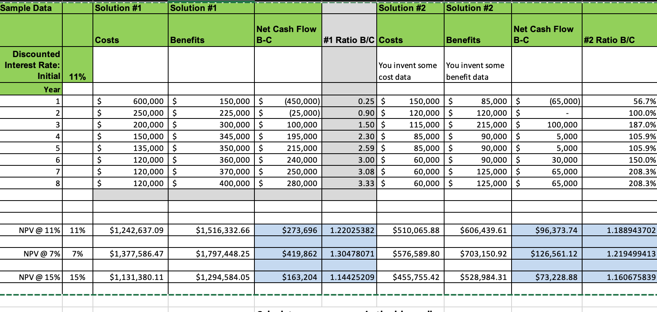

Flow-Chart

